**JAT TASK-6**

**PERSON**

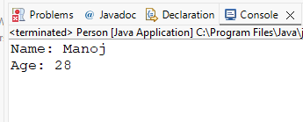

**EMPLOYEE**

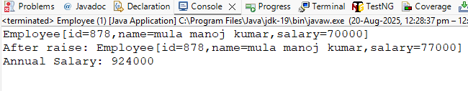

**CIRCLE**

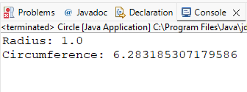

**ACCOUNT**

